JPMC Interview Exercise

Application summary
This is a web application built in React and its purpose is to manage events, where the user can see, create and subscribe/unsubscribe to them.

Guidelines
NOTE: you are provided with use cases, wireframes and API configuration (see Appendix below).
- The application should be written in JavaScript.
- A GUI is required. Use React.js
- Write down all assumptions you make, since you will not be able to ask any questions.
- The source code should be suitable for forming part of the object model of a production application.
- Feel free to use any other external library you may need.
- Unless told otherwise, please submit your responses before 8:00am on the Monday following your first interview.
- Do NOT upload your code to public websites such as github.

Appendix

Use cases
• As a user, I would like to:
o Be able to access a dashboard with a list of events
o See the list of events listed by categories, sorted by date, with the title being the category name
o Have at the beginning a separated title for "Highlighted Events", where I can see 5 random events that have the "highlight" quality.
- Have the events that appear in Highlighted Events, be excluded from the other category lists
- Be able to subscribe/unsubscribe to events
- Create an event with the following fields: Name, Description, Category, Location, Date
- Have the following possible Categories:
  - Work
  - Sportive
  - Lunches
  - Voluntary service

Wireframes
Dashboard
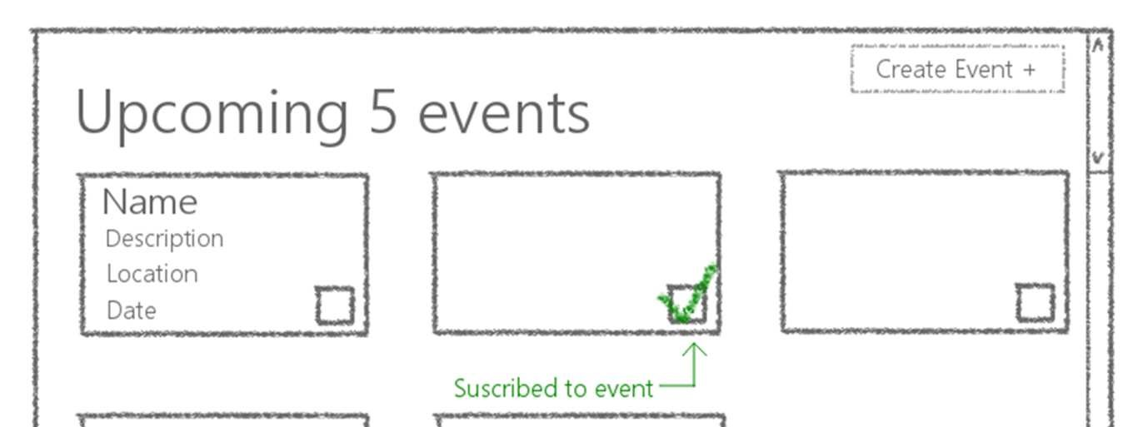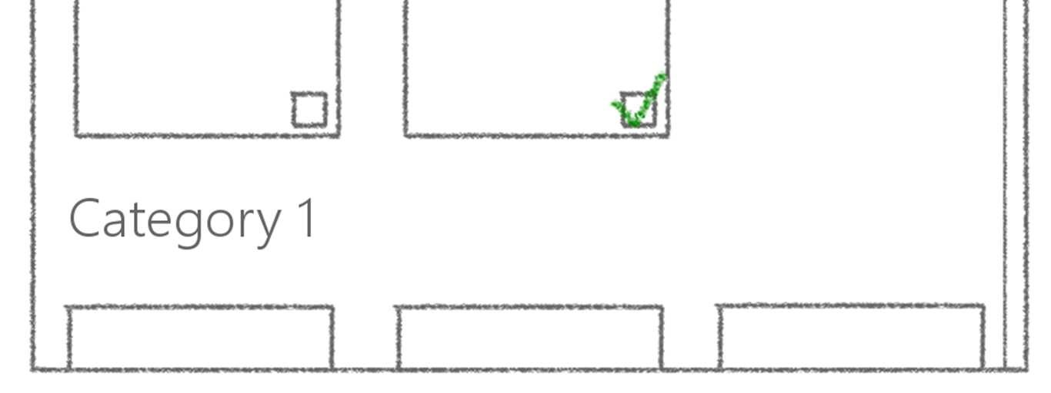

Event Creation
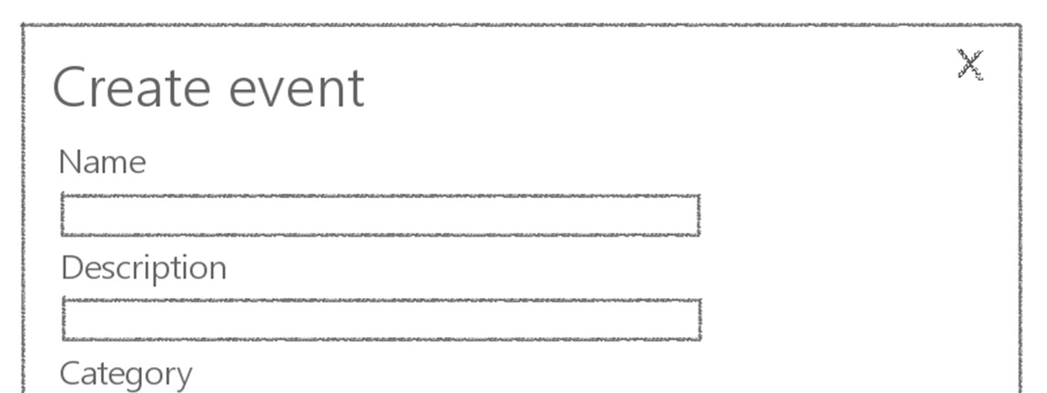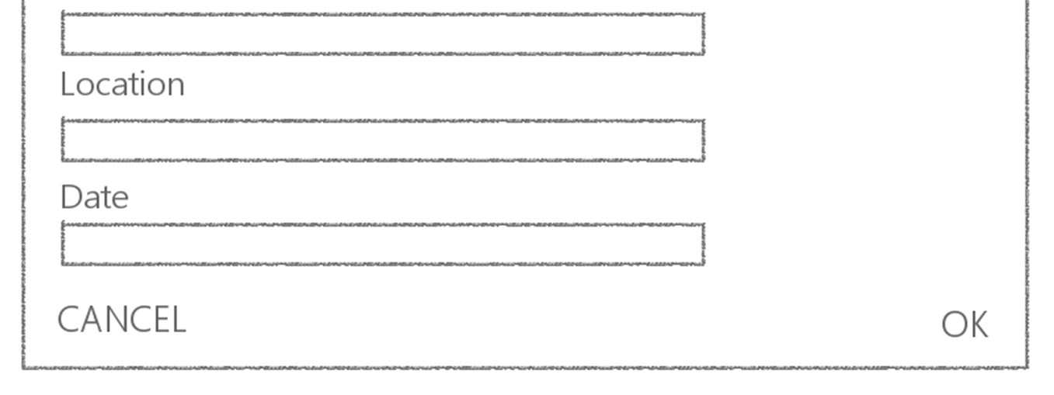

Configure API
In order for the application to run you are going to need a service to fetch and store events. The server will be built using json-server (https://github.com/typicode/json-server):
> npm install –-save json-server

Now we’ll just need to create a db.json file in the project folder root with the following content:
{
"events": [
{
"id": 0,
"label": "SCRUM Alliance Catch-up",
"description": "Monthly catch-up from SCRUM Alliance",
"location": "Palo Alto - California",
"date": "2022-02-02",
"categoryId": 0
},
{
"id": 1,
"label": "Burgers at Mi Barrio",
"description": "Join the whole team for burgers at Mi Barrio",
"location": "Av. Olazábal 1422",
"date": "2022-05-31",
"categoryId": 2
},
{
"id": 2,
"label": "Brazilian Fight Club",
"description": "Jiu jitsu and wrestling",
"location": "Corrientes 242",
"date": "2022-05-01",
"categoryId": 1
},
{
"id": 3,
"label": "Skip level lunch",
"description": "Lunch for networking and team building",
"location": "Root Bar Cafe",
"date": "2022-06-20",
"categoryId": 0
},
{
"id": 4,
"label": "Feed our Bearded Dragons",
"description": "Feed wild & free Bearded Dragons",
"location": "Palermo woods",
"date": "2023-11-10",
"categoryId": 3
},
{
"id": 5,
"label": "Helping goats",
"description": "Come to help our little friends",
"location": "La Noria Bridge",
"date": "2022-08-02",
"categoryId": 3
},
{
"id": 6,
"label": "Pokemon GO classes for elders",
"description": "Come and share your expertise",
"location": "Lanus City",
"date": "2022-10-02",
"categoryId": 3
},
{
"id": 7,
"label": "Wine Taste",
"description": "Come to taste the best wines in Argentina",
"location": "Bodega The Goat",
"date": "2022-01-02",
"categoryId": 2
}
],
"categories": [
{
"id": 0,
"label": "Work"
},
{
"id": 1,
"label": "Sportive"
},
{
"id": 2,
"label": "Lunches"
},
{
"id": 3,
"label": "Voluntary Service"
}
]
}
> \{^_^}/ hi!

Loading db.json
Done

Resources
http://localhost:3000/events http://localhost:3000/categories
Home http://localhost:3000

Type s + enter at any time to create a snapshot of the database
To run the server, execute the following command on a terminal, you should see an output like this:

